**Abstract**

**Introduction**

Management Information Systems (MIS) is the planned system for study of people, technology, organizations, and the relationships among them along with the collecting ,storing and disseminating data of management.

A Geographic Information System (GIS) is a computer system that analyzes and displays geographically referenced information. It uses data that is attached to a unique location.

**Background of the study**

In Recent Years, the information system is developing and use of the resources in different fields are increasing rapidly. For the management of the governmental data and the overall nation data such as Collecting Data, Processing Data, Information Storage, Information Retrieval and information propagation are used to be a challenging task for the governmental workers as well as for the citizen to understand the flow of the management and geographical information system. In terms of shaping state and local government process, workflow, policies and engagement with citizens the geographic information system helps to question how we can improve our environment, safety, economics, infrastructures etc. The study points and to analyze the system that manages the people resources, data resources, software resources, hardware resources and process. Which helps to crime analysis, law enforcement, and public safety and land records.

**Problem of the study**

Governments are facing the corruption, data inefficiency about the economics, state structure, resource allocation, law enforcement, public safety, geographical structure and the other management processes. Implementation of the information system helps in proper process but due to the lack of knowledge of the management and the geographical structure along with activity data of that particular state. The Management and Geographical Information System is poorly conducted to modernize operations, gain new perspective on the balance between natural and built environments, and create equitable and inclusive policies.

**Objective**

The Objective of this study is to clarify how the management and Geographical Information System helps in developing local governance. They are as follows:

1. Knowledge of the data collection, storage, retrieval and propagation
2. Crime Mapping
3. Management of public Transport and Works
4. Environments and Natural Resources

**Research Questions**

1. How local government utilize and manages the data of the citizen, environment and natural resources?
2. How is GIS different from using traditional, hand-drawn maps?
3. What are the local government key directives for the strategic directions of GIS?

**Scope and Limitations of the Study**

**Significance of the study**

**Related Work**

Some Related work done in government along with business operation rely on the management and graphical information are:

1. Land-use planning
2. Subdivision review
3. Permit tracking
4. Parcel/tax mapping
5. Engineering design
6. Road and utility maintenance
7. Event (crime, fires, accidents)
8. Reporting
9. Emergency management
10. Infrastructure assessment and development
11. Cartography
12. Environment
13. Property management

**Current Situation of E-Governance**

**Research and Methodology**

As our topic stands for management and geographical information system, we utilize the internet as the quantitative methods (analysis on existing data).Our aim is to find how the local government utilize and manages the management and geographical information system.

**Quantitative methods**

Existing Data:

1. we managed to find some useful information about the GIS in the website (<https://www.geospatialworld.net/article/gis-is-an-important-tool-for-local-government/>)

**Qualitative methods**

Existing data: AS a group, we observe the structure and the visual aid to understand the process flow used in management and geographical information system done in the local government.

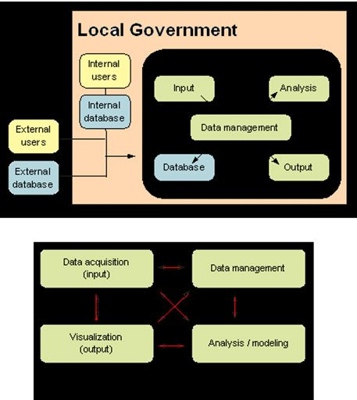

**Implementation**

**Conclusion**

**References**

<https://www.geospatialworld.net/article/gis-is-an-important-tool-for-local-government/>